**Truncate 테이블 내용 삭제**

1. **Select * from sample62;**
2. **Insert into sample62 values(1,’abc’,’2014-01-25’);**
3. **Select * from smaple62;**
4. **Truncate table sample62;**
5. **Select * from sample62;**
6. **Desc sample62;**

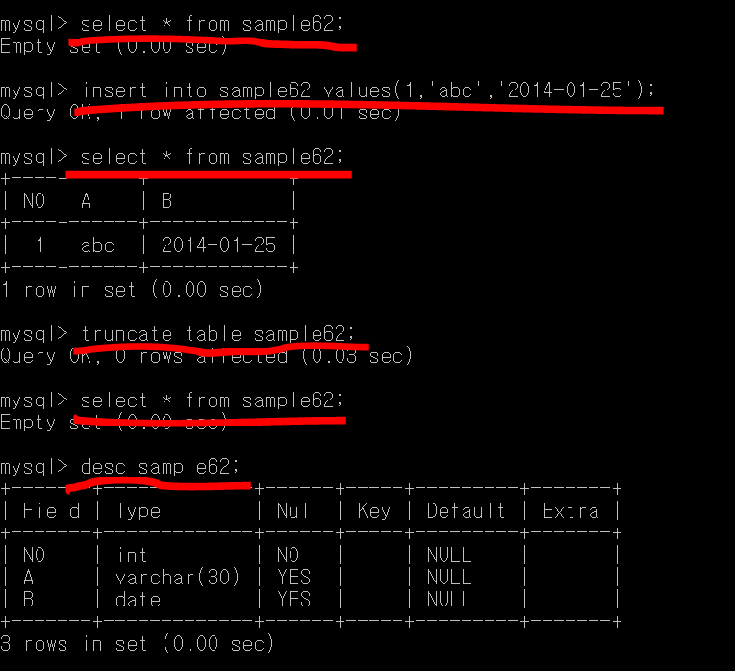

**Truncate 테이블에 있는 내용을 삭제한다**

**스키마는 유지된다**